[**http://web.cse.ohio-state.edu/~reeves.92/CSE2421sp13/PracticeProblemsY86.pdf**](http://web.cse.ohio-state.edu/~reeves.92/CSE2421sp13/PracticeProblemsY86.pdf)

**1.**

**Fetch (Matthew)**

First, the fetch_instruction_memory unit reads 10 bytes of memory at a time, from the PC register. Then, the first byte is split into two 4-bit sections, one for icode and one for ifun. The remaining 9 bytes read from instruction memory are fed into the align unit. In the align unit, the first of 9 bytes is split into registers rA and rB if need_regids unit outputs 1. If this is the case, bytes 2-9 will be assigned to valC. Otherwise (if need_regids =0), then bytes 1-8 will be assigned to valC since there is no data for rA and rB. Need_regids takes in icode, and if icode is equal to (in hex) 2, 3, 4, 5, 6, a, or b, then need_regids will be set to 1, indicating that rA and rB need to be set. The need_valC unit works similarly. If icode is equal to 3, 4, 5, ,7 or 8, then need_valC outputs 1, indicating that valC exists and should be considering in updating PC. Lastly, the PC increment unit generates the value valP, based on the values PC, needs_regids (r), and need_valC (i). valP is PC + 1 + r + 8xi.

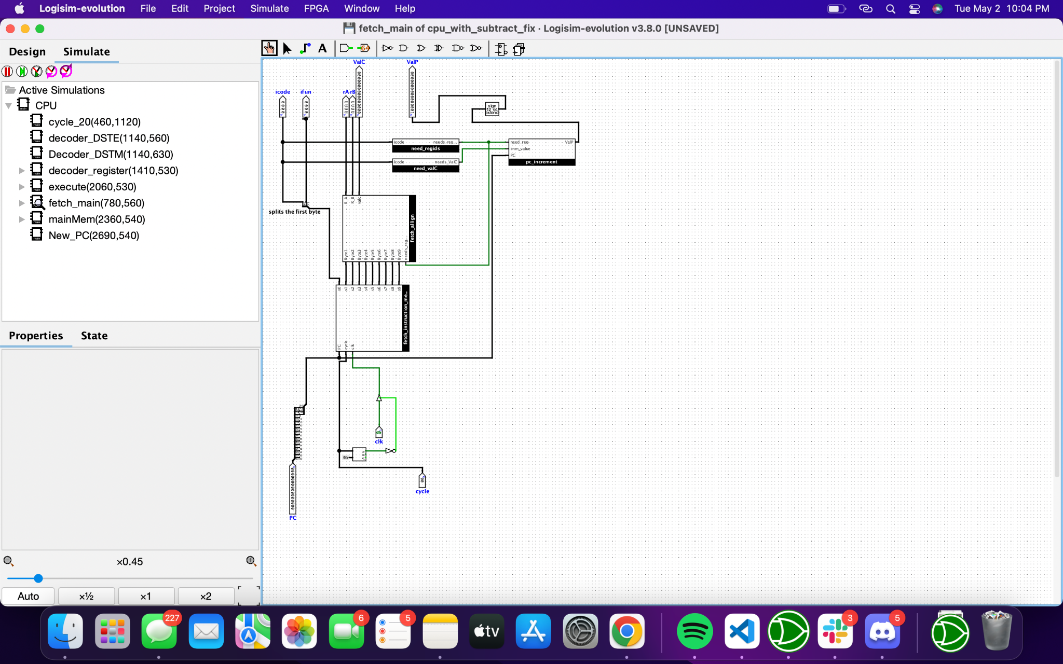

**Decode & Write Back (Ani)**

The decoder consists of 3 components, the DSTE, DSTM, and the Register File. The DSTM component will output a 4 bit value from rB as the memory address for the register file for where ValM should be stored. This output is also dependent on the input from icode. If the inputted instruction requires the writing of ValM to the register file, it will output valM, otherwise it will output 0xf. The DSTE component will also output a 4 bit value but using rA and icode as an input to determine whether or not to output rA as the register address for ValE from execute or to output 0xf as the icode determines the value of ValE will never be needed for the instruction. The decoder register file recives inputs of ValM and ValE for inputting values into the register file, inputs of dstM and dstE for memory addresses to write to register, inputs srcA and srcM for memory addresses to read from registers, cycle & cycle count, and finally icode to determine when stack operations must be done to register %rsp. The register file is responsible for storing 15 registers for quick read and write access based on the given inputs. It uses 2 sets of 2 decoders with 4 bit input for determining which register to access for read and write respectively. The registers are only allowed to write to after 19 cycles of the clock have passed so that all memory access operations are completed before their inputs valM and valE have populated into the decoder register as inputs.

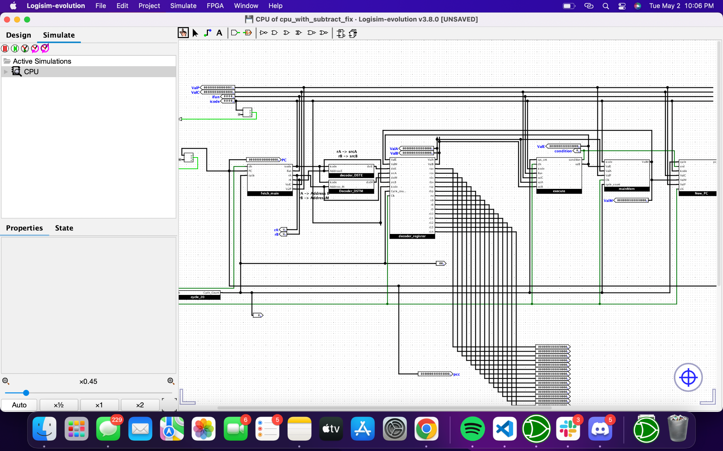

**Execute (Maddie)**

This stage includes the ALU, which performs the operations: add, subtract, AND, and XOR, based on the value of the 2-bit signal alufun. The ALUA unit chooses between valC and valA based on the instruction. Similarly, ALUB unit chooses between valB and 0 based on the instruction. ALUFUN unit chooses between the last two bits of ifun (funcType) and 0. If icode is 6 or 7, then funcType is chosen, otherwise 0 is chosen. Next, the outputs of ALUFUN, ALUA, and ALUB are passed into the ALU. funcType determines the operation that is performed between the other two inputs, and the result is valE. ALU also sets the condition flags s, o, and s, which are the zero flag, the overflow flag, and the sign flag. Execute also includes setCC and cond_exec. Set_cc outputs 1 only if icode is equal to 6. This output signals to the cond_exec whether or not a conditional branch or data transfer should take place. Cond_exec will output 1 or 0 based on the value of ifun and output of setcc.

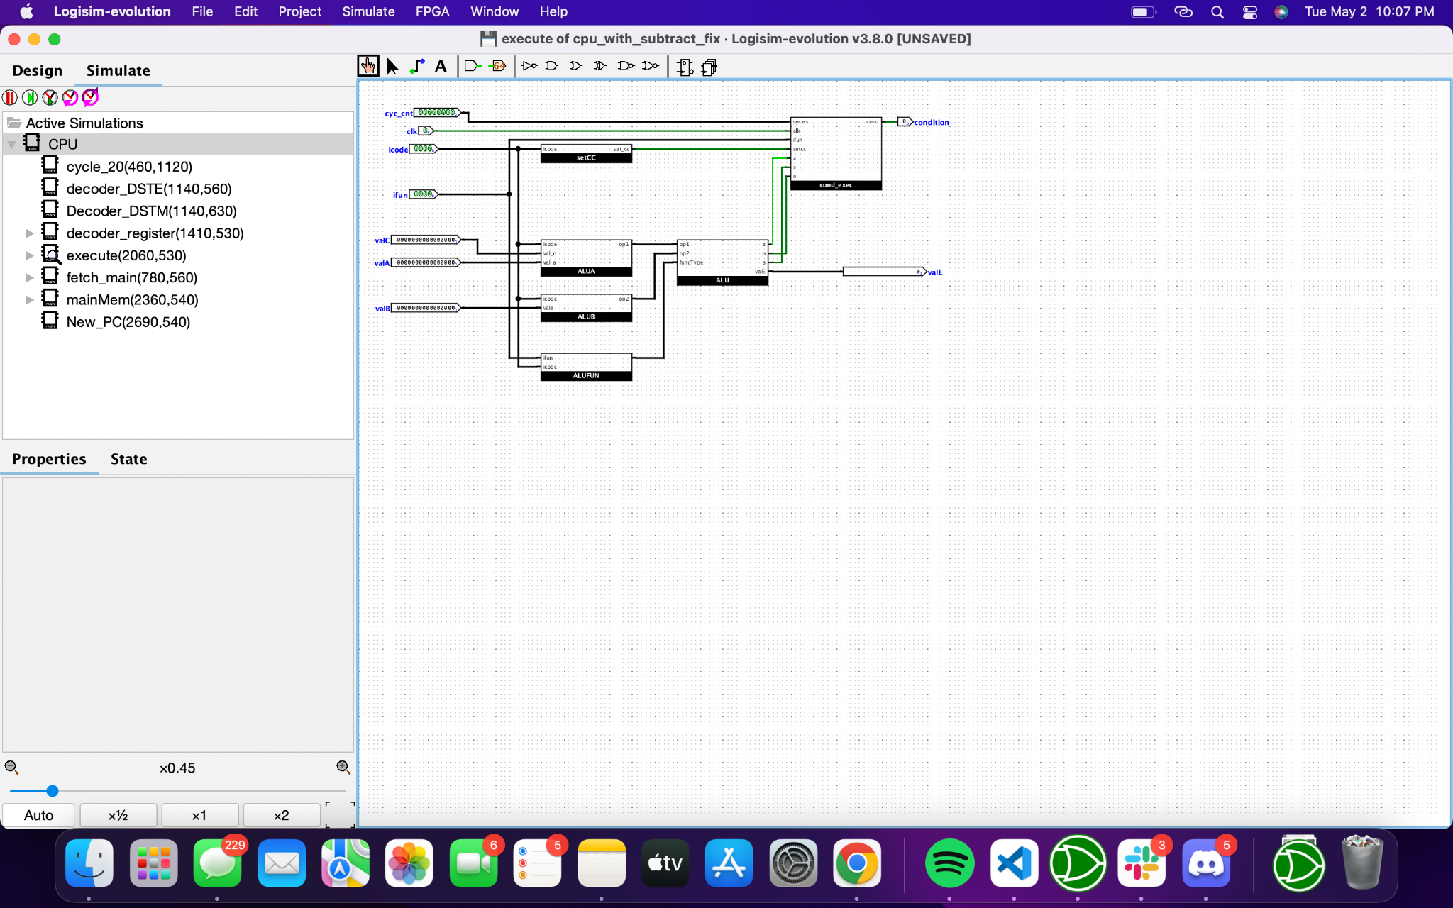

**Memory (Brian)**

Memory stage either reads or writes the program data. memRead and memWrite units determine whether to write to memory or to read memory. In memWrite, if icode is 2, 4, 8, or a, then memWrite outputs 1. In memRead, if icode is 5, 9, or b, then memRead outputs 1. For wire operations, memAddr and memData unit are used to select the correct address and data line to write to. In memAddr, if icode is 2, 4, 5, 8, or a, then valE is selected to be the address. If icode is 9 or b, then valA is selected to be the address. memData works similarly. If icode is 2, 4 or a, then valP is the data to be written. If icode is 8, then valA is the memory to be written. valM is the output of the data memory when it is a read operation.

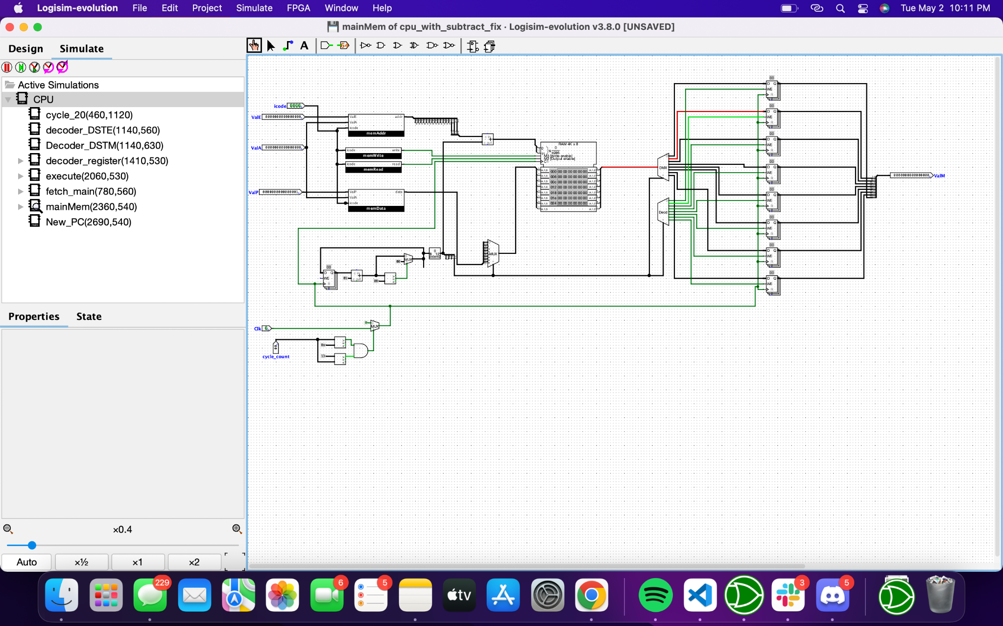

**New PC (Ani, Brian, and Matthew)**

In the new PC stage, new PC will be updated to either valE, valM, or valP, depending on the instruction. For example, valP is used for instructions mrmovq and rmmovq, valM is used for ret, and for jump instruction, valP or valC is used depending on the value of condition.

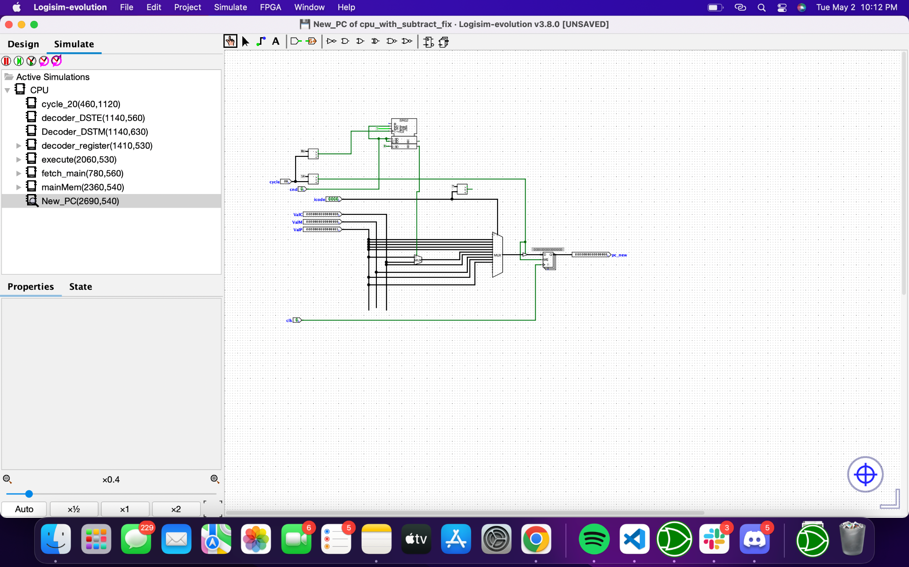

**2. Timing Diagram:**

